When UI elements (SliderBarWithEcho) does not show,

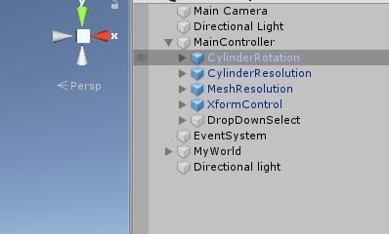

Select the element (CylinderRotation) drag it out of MainController (containing Canvas) and drag it back again. The position needs to be re-worked. But this will make the UI show!